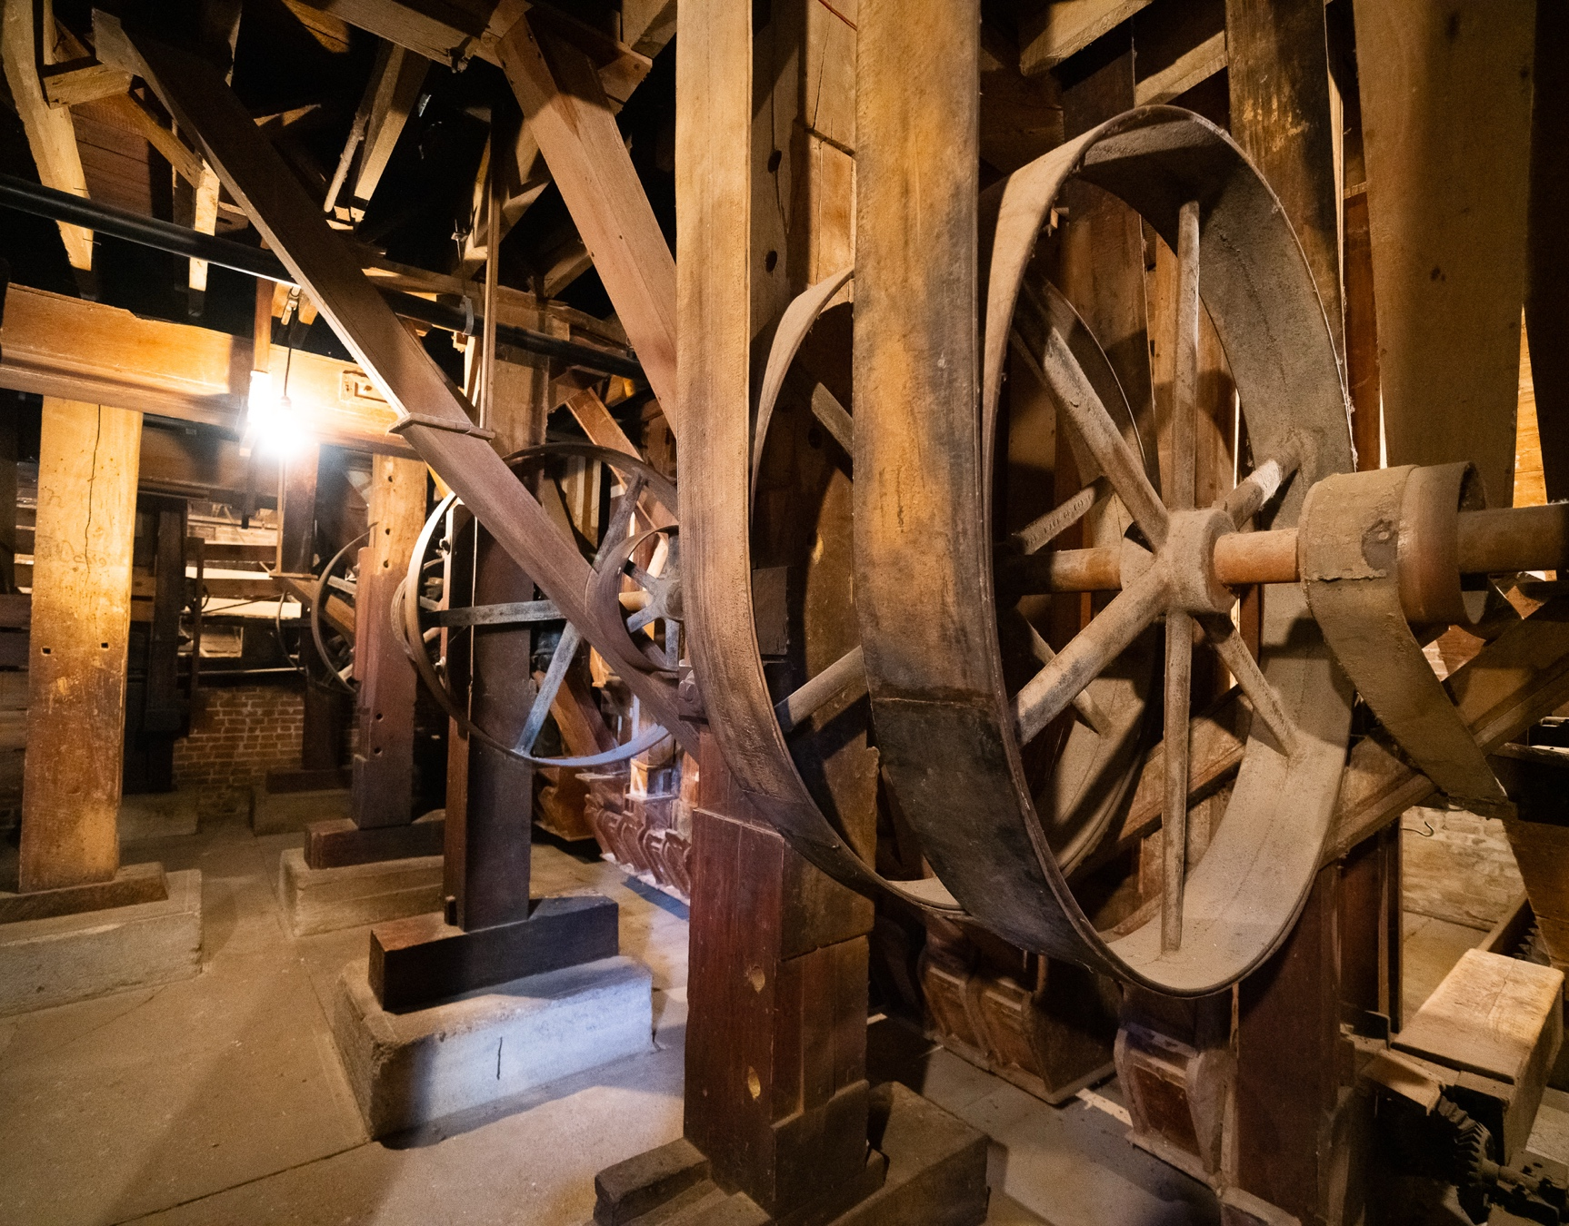

STRATEGIC PLAN

2025-2030

City of Neligh

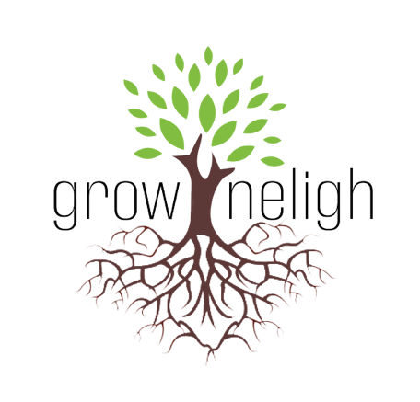
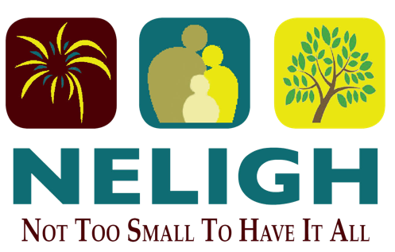

Table of Contents

Introduction ……………………………………………………. 3

Infrastructure …………………………………………………... 5
Housing ………………………………………………………….10
Economic Development …………………………………… 12

Introduction

Neligh’s Strategic Plan acts as a guide for the City’s future direction. It outlines strategies to reach its goals. Neligh strives to build a strong community through financial stability, engagement, beautification, aesthetic upgrades, new amenities for all ages, improved public infrastructure, and better public safety services, ensuring it is prepared for growth.

The City of Neligh has spent the past year completing a planning process that includes multiple unique opportunities for public input, goal determination, and various planning documents. All completed documents were designed to work together better to equip City leaders for action strategies and decision-making while progressing with the community. The Comprehensive Plan serves as the community’s long-range plan, outlining goals and objectives for the next 10 to 15 years in Neligh. This Strategic Plan document encompasses many of those same goals and objectives; however, it establishes short-term goals for City leaders to pursue over the next five years. These goals are comprehensive, addressing various aspects of the community, including streets and sidewalks, housing, and recreational amenities. The overall opportunities for success highlight the importance of these goals, but they will all require hard work, planning, and budgeting. Additionally, many of these goals will need support from the local community, as not all of these objectives can or should be completed by the City.

The City of Neligh is committed to ensuring a healthy future for its residents and providing the services they expect. The City will strive to effectively and efficiently develop and enhance assets that contribute to making Neligh a wonderful place to live, work, and play.

Goal setting is an important step for individuals, families, businesses, and even communities. City leaders need to establish clear long-term and short-term goals, along with strategies to achieve these objectives. However, these goals must be comprehensive, considering every aspect of the community, and they all must align with a single vision for the community's future. Personal and business goal setting is no different; it may just be more challenging at the city level due to the various aspects and components city leaders must constantly assess and direct to grow and change in an organized, efficient, and effective manner. The City of Neligh completed its Comprehensive Plan Update in 2014. This plan enabled residents and community leaders to collaborate in creating long-term growth and development goals for the City. The following is a list of the City’s long-term goals determined by residents and stakeholders:

Improve Public Infrastructure
Improve the Existing Housing Market
Promote Commercial Development
Expand Recreational Attractions and Amenities
Continue Marketing Campaigns and Enhance Community Beautification

These goals combine information gathered from public input sessions held during the

planning process, research, and data analysis are essential. Their importance stems from their realistic nature, enabling the community to have ongoing objectives to pursue over the next ten years. While long-term goals are significant, achievable short-term goals are critical for stakeholders to accomplish. The City of Neligh utilized public input sessions, surveys, and data analysis from the planning process for the Comprehensive Plan, in addition to a meeting with City staff to set practical five-year goals for the City to attain.

The Neligh Economic Development Office (NEDO) created its own Strategic Plan in 2014, outlining NEDO’s goals and objectives to achieve over the next five years. The complete NEDO Strategic Plan is available on the City’s website or by visiting the office of the NEDO Director located at 105 East Second Street in Neligh. NEDO’s Strategic Plan identifies three main goals: Energize, Enhance, and Grow. Each goal includes several listed objectives, and it is the responsibility of the NEDO Director and Board members to achieve these objectives in order to fulfill their goals of energizing, enhancing, and growing Neligh. These goals and objectives are incorporated into the City’s overall Strategic Plan with the understanding that the City of Neligh, NEDO, and the residents must collaborate to reach their goals.

All of the above goals are included in this Strategic Plan, with a range of projects divided into two distinct timelines. The first set of goals includes projects that City staff hopes to accomplish within the next one to two years, while the second set comprises projects that City staff aims to finish within the next three to five years. These projects are categorized into three areas: infrastructure/public services, housing, and economic development.


Infrastructure
The City of Neligh will enhance its public infrastructure through several phases of upgrades and improvements over the next five years. Public services and infrastructure are vital to the community. Neligh aims to ensure its infrastructure and services meet the needs of current residents while also accommodating future growth as necessary. The City of Neligh will make certain that public investment is utilized effectively by promoting balanced public investment and reinvestment opportunities in essential areas, including public services and infrastructure that contribute to a high quality of life for all residents. There are specific projects the City hopes to accomplish over the next five years through several phases, ranging from paving to water and recreational amenities to technological infrastructure needs.
Provide high-quality public services and infrastructure for current residents, ensuring the capacity to expand and accommodate future growth as needed.

Below is a list of goals regarding infrastructure improvements that the City will achieve over the next five years:
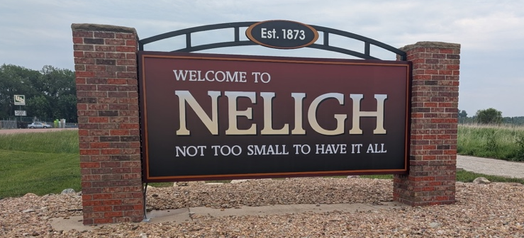
- Budget Annual Maintenance Fees;
- Water Distribution Improvements;
- Paving Street and Sidewalk Improvements;
- Continued Enhancement of Technology
Infrastructure; and
- Improve Recreational Amenities

The City recognizes that improving public infrastructure is an ongoing process; however, this plan focuses its examination on the next five years.

Budget annual maintenance funds for streets, water & sanitary sewer.
All projects outlined in this section of the Strategic Plan will be included in the City’s Capital Improvement Plan (CIP). Since these public service and infrastructure needs are expensive for the community, the City must budget annually for general maintenance and improvement needs to avoid unnecessary costs caused by deteriorating infrastructure.

Water distribution improvements
The City of Neligh currently maintains Nebraska Public Water Supply No. NE3100305. The current system supplies water to its residents and businesses through four active groundswells, a 250,000-gallon storage facility, 761 metered services, and approximately 18.7 miles of distribution main. The four active wells were constructed in 1957, 1973, 1984, and 2004. The average daily demand in 2024 was 232,000 gallons. The system has a maximum capacity of 2,411,516 gallons per day. Recent work on the system included extending the water main to the east, including areas of the Countryside Acres subdivision and Highway 275, to provide City services to marketable areas for commercial and residential development.

Electric Improvements

The City of Neligh is dedicated to improving its electrical infrastructure moving forward. In 2023, automatic controls were added to the Electric Generation Plant, enabling faster start-ups to supply power during emergencies or when a power provider requests Neligh to serve the community directly due to grid strain. These automatic controls also allowed for new power agreements for the city that were not possible with manual controls. Electric meter upgrades were completed, enabling city personnel to read, connect, and disconnect services from city hall or remotely using a mobile device. This upgrade ensures faster responses and shorter activation times. Mapping of the entire city’s electric grid was also finished. Electric outages can now be accessed on a tablet for quicker response times and more efficient service issue corrections. The city is also upgrading the emergency notification system and replacing outdated sirens to cover a larger area.

Future projects include boring new underground lines on North Q Street and East 5th Street. Phase 2 of the electric meter upgrades involves continually adding new meters to replace older ones and expanding city coverage with new readers.

Paving, street, and sidewalk improvements

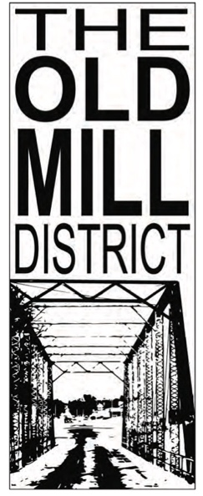
Some roads need improvement. Neligh has a large percentage of concrete roads in the community. Although concrete is not the only street surfacing option, it has the longest lifespan and requires less maintenance than other types of road surfacing; therefore, concrete roads are a good investment for the community's future. The City aims to eliminate all gravel streets in Neligh; however, short-term goals will focus on the plan outlined below.

Some roads need improvement. Neligh has a large percentage of concrete roads in the community. Although concrete is not the only street surfacing option, it has the longest lifespan and requires less maintenance than other types of road surfacing; therefore, concrete roads are a good investment for the community's future. The City aims to eliminate all gravel streets in Neligh; however, short-term goals will focus on the plan outlined below.

The city plans to include a one-half percent increase in sales tax on the 2026 ballot for public infrastructure, including street improvements to pave or asphalt gravel roads. The city is also reviewing a possible cost-share program for residents to improve sidewalks for public safety. The 2025-2026 budget year includes continued maintenance of existing streets. It also includes Armor Coat on D Street and Baker Road, as well as milling of the existing asphalt overlay on concrete streets. Maintenance of existing streets is crucial to the city’s progress and transportation needs.
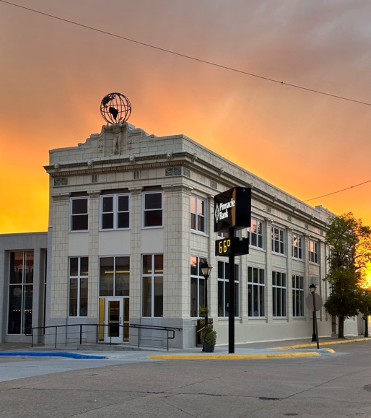
In the Community Needs Assessment Survey, a majority of community members feel that the condition of sidewalks and street infrastructure is below average. This was reiterated as necessary from a Nebraska Community Foundation Youth Engagement Survey and follow-up session with a small group of students. Updates will need to be made continuously to improve these community aspects, and some sidewalks in Neligh require enhancement. A sidewalk inventory should be utilized to assess areas that need sidewalks as well as existing sidewalks that need repair. The inventory would evaluate each sidewalk and ramp (or any absence of them) to determine the overall needs of the community.

The City aims to improve sidewalks and make them ADA compliant; however, it should focus on the following short-term goals for the next five years. Developing a cost-share program between the City and property owners to split the costs for the new improvements can encourage residents to contribute some of their funds to assist in the development of ADA accessible sidewalks. The City should allocate a specific amount each year, allowing residents to apply for funds from that budgeted amount to help make these enhancements throughout the City. Ensuring pedestrian accessibility across the community is essential for residents, particularly between key locations in the City such as the swimming pool, school, Old Mill District, medical facilities, public parks, and library.


Continual Enhancement of Technology Infrastructure
Neligh has four fiber optic providers, including Great Plains Communications, Stealth Broadband, and Nebraska Link. Infrastructure for technology advancements is crucial in today’s economy; therefore, Neligh is truly positioning itself for better growth in the business sector by offering technological resources that other similarly-sized communities lack. Continually improving this infrastructure and marketing it to potential businesses is vital for the economic success of Neligh. The city will continue to collaborate with the existing fiber optic providers to enhance and expand this infrastructure.

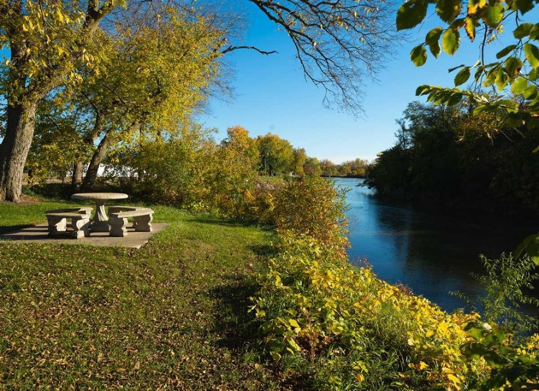
Improve Recreational Amenities
A complete list of desired recreational improvements can be found in the Comprehensive Plan. The following list of projects was identified as the priority goals for the community’s recreational amenities.

Neligh offers a variety of playground and picnic equipment to serve families and children of all ages, including the newly added Phase I of an all-inclusive playground. Existing park equipment will be regularly monitored to determine when improvements or replacements are needed, ensuring Neligh’s parks remain a safe environment for children to play. City stakeholders also expressed their interest in adding more playground equipment or creating another “neighborhood” park on the opposite side of the community to offer a recreational space near residential areas.

A new swinging pedestrian and ADA bridge crossing the Elkhorn River opened in 2024, providing access for walking and mobility devices to both Riverside and Russell Park, and revitalizing Russell Park. In 2025, two new shelters with picnic tables were constructed to enhance the enjoyment of the river and nature. A new ADA fishing dock was installed at Fred Penn Park, along with a nine-hole disc golf course in Riverside, with plans to extend an additional nine holes in Russell Park. A new three-person pull-up bar was also added at Riverside Park for fitness enthusiasts and is used during the annual Murph Challenge fitness event on Memorial Weekend.

Neligh’s public pool also received essential upgrades, including a new pool liner, significant updates to the underground plumbing, a new circulation pump, a new pool deck, upgraded lighting, and improvements to the bathhouse and sound systems. Security cameras were also installed at the pool and tree dump for enhanced security. New underground sprinklers were installed at the ballfields. A new batting cage and a new north ballfield restroom were also built in Riverside Park. The existing restrooms near the concession stand were remodeled, and the concession stand and restrooms received new exterior paint. Eight camping spots were added to Fred Penn Park, which includes water and electric hook-ups for campers. Additionally, the Fred Penn Park building exteriors received new paint and additional security lighting.

Plans are underway to complete Phase 2 of the all-inclusive playground at Riverside Park, which will add four more pieces to the existing three-piece playground, resulting in a total of seven pieces of all-inclusive playground equipment. The existing tennis court in Riverside Park is being renovated into a pickleball court outfitted with adjustable basketball hoops. A dog park will be added to Russell Park, providing a separate, fenced-in area for dogs of all sizes to run. A new 2-inch water line from Riverside Park under the Elkhorn River to Russell Park is planned to add hydrants for watering the new grass and trees, as well as to accommodate the dog park and shelter anticipated at the site.

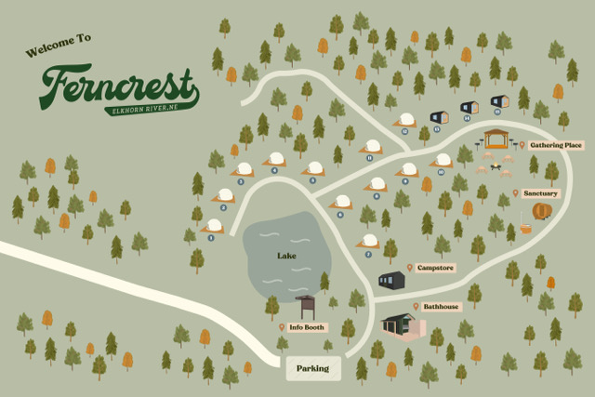
The Tallgrass Retreat, offering “glamping,” is a new destination located south of Russell Park and is scheduled to open in spring 2026. It will feature luxury dome structures with wood-burning fire stoves, microwaves, AC, coffee stations, up to king-sized premium bedding, and hot tubs. The retreat will also offer a cabin option, a camp store, an event center, and RV parking. It is part of the Ferncrest franchise, which has locations in Oklahoma and Pennsylvania. Conveniently situated along the Elkhorn River, it provides walking access to Russell and Riverside Parks and is ideal for attending the Antelope County Fair or the Quad County Tournament.

The Cowboy Trail and other trails attract a lot of recreational activity in the city, as they provide a safe environment for exercise, including walking, running, biking, and skating. The community has expressed a desire to have a concrete hike/bike trail constructed around Penn Lake to serve as an additional recreational amenity. When marketing Neligh, greater efforts can be made to utilize the Elkhorn River for recreational activities such as tubing, fishing, kayaking, and canoeing, paired with these additional hiking and biking trails in the community. The city is collaborating with Bike Walk Nebraska to enhance amenities and improve access along the trail, working with the Nebraska Game & Parks Department and Cowboy Trail Coalition to help implement a continuous coast-to-coast trail throughout Nebraska.

Housing

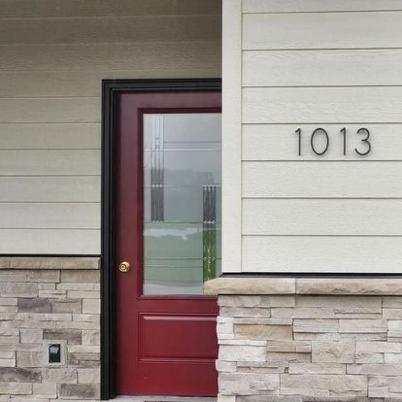
Housing is a crucial component of Neligh's prosperity. Whether it's identifying the need for new market-rate housing or finding ways to encourage the development of affordable housing options, Neligh must constantly assess and improve its housing market. To attract more people to the community, there needs to be a supply of well-maintained, available, affordable, and safe housing. While projecting future demand is essential, it can sometimes be a challenging task when promoting growth in any community. Addressing the issues of aging housing stock that fails to meet the needs of today’s renters and buyers is another challenge facing City leaders. Community growth and revitalization can be achieved by identifying housing needs in Neligh.

The following is a list of the housing improvements the City plans to make over the next five years:

- Work with Local Businesses to Determine Housing Needs
- Demolition of Vacant, Dilapidated Structures - Nuisance Property Enforcement
- Housing Beautification Encouragement
- Work with Developers and Local Contractors
- In-Fill Housing Development

Work with Local Businesses to Determine Housing Needs

The City should collaborate with local businesses to identify the housing needs of their employees. Engaging with local businesses demonstrates the City’s support for them. It cultivates communication between the City and employers, allowing for the exchange of valuable information. Some businesses may also provide down-payment assistance for their employees; others have purchased homes to rent to them in the tight housing market, and some may even help build speculative housing for new or existing employees. Investment
groups could also be formed to develop speculative housing in Neligh. Many people are often hesitant to build a new home independently. If a group of residents could initiate this process, it might benefit current and potential residents and provide some relief for the housing market.

Demolition of Vacant, Dilapidated Structures

All vacant lots and uninhabitable homes are properties that could be used for infill residential development. The City should explore various options to assist with the cleanup of these vacant lots and properties. Although there aren't many lots available for infill development, efforts must be made to increase availability. By cleaning up vacant lots and uninhabitable homes, the City will eliminate unsightly views and address safety and health hazards in the community. Several methods exist to continue demolishing vacant, dilapidated properties, including Tax Increment Financing funds, City-funded acquisitions, or encouraging property owners through nuisance abatement. The City should allocate a specific dollar amount each year to support the acquisition and demolition of vacant, derelict homes.

The city took an active approach to reducing the nuisance properties with a new Nuisance Property ordinance, which resulted in the demolition of numerous nuisance and dangerous buildings and repairs to others. Enforcement is an ongoing priority of the city. The city also adopted the International Property Maintenance Code, allowing the City Superintendent to inspect the interior of buildings following a complaint about the safety of the home and reducing undesirable landlord-owned properties that are unfit for occupancy.

Housing Beautification Encouragement

The citizens of Neligh have expressed their concerns about a housing beautification initiative through various channels. The City and the Neligh Economic Development Office will seek to establish a housing beautification program, which may include a beautification incentive, coordinating a volunteer effort, or encouraging the enforcement and extension of the current nuisance ordinance.

Work with Developers and Local Contractors

The City adopted a Workforce Housing Plan in 2021. In 2023, the city partnered with the Neligh Chamber of Commerce to address the need for affordable housing options for local employers. That same year, the partnership received a Nebraska Department of Economic Development Rural Workforce Housing Grant. The program provides very low-interest construction loans to qualifying developers. It will continue to develop more housing options for sale and rent. Additionally, it supports local contractors, boosts local businesses by purchasing materials, and expands the sales tax base.

Infill Development

The City must continue to actively promote infill development as a key strategy to expand the local tax base. By prioritizing growth within existing developed areas and using current infrastructure, the City can lower the costs of providing services while also revitalizing underused properties, strengthening neighborhoods, and supporting sustainable, long-term economic growth.

Economic Development

The City of Neligh will enhance the business climate of the community by focusing on sound economic development principles. The City will promote and emphasize private and public investments in the City’s Old Mill District and along its highway corridors. The City aims to ensure a vibrant mix of thriving businesses that provide goods and services to the community, enhance the City’s quality of life, and meet the needs of residents.

Below is a list of goals to improve Economic Development for the City of Neligh over the next five years:

- Youth Retention
- Revitalize Downtown
- Workforce & Continuing Education Development
- Marketing Neligh
- Develop Partnerships & Align Resources
- Continue Effective Business Retention & Expansion Program
- Business Attraction

Work for Youth Retention

Attracting and keeping youth in Neligh is essential for the community. Therefore, the City, with support from groups like the Neligh Economic Development Office, will collaborate closely with Neligh-Oakdale School staff to make sure Neligh’s youth feel welcomed and see the many opportunities available if they choose to stay or return after further education. Different organizations within the City need to identify who will be responsible for various youth retention programs. Hosting local business tours and the Antelope County Career Fair with students can highlight local businesses and career options. Developing an entrepreneurship and apprenticeship program can help keep youth in the community; stakeholders should seize these opportunities to engage young people while they are in Neligh. The city will also stay connected to the Nebraska Community Foundation to support youth education and attraction.

Revitalize Downtown

A thriving and lively Main Street has long been a key feature of a prosperous community. The City has worked hard to improve the facades through the Nebraska Department of Economic Development’s Downtown Revitalization Program and continues to provide façade grants to local businesses. Empty lots in the downtown Old Mill District should be filled with retail and basic service businesses. The Old Mill District also needs well-maintained sidewalks, attractively decorated storefronts, and active businesses. These businesses should offer retail and entertainment options that draw pedestrian traffic throughout the day, evening, and weekends. In forums, the public expressed a stronger desire for clothing boutiques, more dining choices, and a coffee shop with free Wi-Fi.

Enhance Workforce Development & Continuing Education

The Neligh Economic Development Office should continue using Location One Information Systems (LOIS), an online database that the State of Nebraska and many other states use to share current information with potential businesses. The City should promote the community to prospective business developers, and while working to attract new businesses, it should also partner with employers to assess their workforce needs and attract talent to the community. Employers will be encouraged to participate in the biannual Antelope County Career Fair. Marketing and recruiting potential businesses should remain an ongoing effort by the City, the Neligh Economic Development Office, and local businesses.

Marketing Neligh

The City of Neligh and the Neligh Economic Development Office need to continue marketing the community effectively to both current and future residents through various programs and initiatives. This includes updating and promoting the "This is MY Neligh" campaign and strengthening a comprehensive shop local program to support small businesses and encourage community pride.

A strong, recognizable community brand, strategically marketed to residents, visitors, and prospective investors, is crucial for creating a positive image and ensuring long-term sustainability. Social media remains an essential tool for sharing timely information with residents while highlighting Neligh’s unique offerings to potential new residents and tourists.

Additionally, the Discover Neligh app serves as a powerful platform for both residents and visitors by providing easy access to local business listings, upcoming events, historic attractions, community resources, and more. The app not only supports local businesses and tourism but also enhances community engagement by keeping users connected and informed as new features of the app are developed.

Moving forward, the City and Economic Development Office should keep using digital tools like the app and social media, while also trying new marketing channels. Sharing Neligh’s story, its quality of life, available incentives, development-ready sites, funding options, and civic strengths will be key to attracting private investment, encouraging economic growth, and supporting the vision of a self-sustaining, lively rural community.

Develop Partnerships & Align Resources

The City and the Neligh Economic Development Office have continued working to establish and strengthen quality partnerships with State and Regional offices and organizations that can support Neligh and vice versa. Building partnerships and forming relationships that improve access to funding resources in the area, including regional, state, and federal agencies, could be helpful. Coordinating development incentives from local to regional to state levels may help attract potential businesses to Neligh. When marketing any real estate, the City should also highlight the development incentives available in the area. Developers considering a new commercial venture take into account how development incentives can influence their choice of location. Providing clear and easily accessible information about all development incentives will benefit the promotion of development in Neligh. The City should also continue using the Attraction, Start-up, and Transition Electric Incentive program. Additionally, the City will promote the Façade Grant and Digital Façade Grant programs to improve the digital presence of businesses and expand sales beyond the community.

Continue Effective Business Retention & Expansion Program

Over the past ten years, Neligh has welcomed 58 new businesses with an 81% success rate and 21 transitioned businesses, also achieving an 86% success rate. For the City to continue thriving, it must focus on retaining existing businesses and attracting new ones. To do this, the City and Neligh Economic Development Office should strengthen efforts to keep and grow local businesses through the ongoing Business Retention and Expansion (BR&E) program. This program builds relationships with business owners and facilitates communication between the City, the Neligh Economic Development Office, and local businesses. It ensures that the Neligh Economic Development Office understands the needs of business owners, can assist with employee recruitment when needed, supports expansion efforts, seeks potential grant funding or other development resources, and helps with succession planning.

Business Attraction:

The Neligh Economic Development Office has launched a business attraction program to grow the community's business base. The recruitment of new businesses should depend on their likelihood of success in the region and their ability to complement existing industries, especially agriculture, which is vital for Neligh's progress and growth. Expanding this sector with complementary businesses could benefit the city and support current agricultural enterprises, possibly leading to necessary expansions. The city should also consider providing space for service sector businesses, as well as potential manufacturing or light industrial operations. Prioritizing prime areas for commercial development is essential. These areas should have access to a broader transportation network, good visibility, available land, and proximity to existing city limits. Additionally, the city should develop an annexation plan for prime commercial real estate and keep an up-to-date, comprehensive list of Blight and Substandard Analysis for this property.

